**Worksheet 1b: Inputs, processes and outputs**

**Activity 1(Secure)**:

Identify the inputs, processes and outputs for the following real-world applications:

|  |  |  |
| --- | --- | --- |
| **Passport Scanner (**[**Details**](http://www.passportscanning.co.uk/?gclid=CJH999rmr7oCFXHJtAodLC0A0A)**)**  **Input:** *Passport barcode is scanned*  **Process:** *Data from barcode is checked against national database*  **Output:**  http://www.wi-ltd.com/images/product-images/1118.jpg |  | **Automatic Windscreen Wiper (**[**Details**](http://auto.howstuffworks.com/wiper4.htm)**)**  **Input:**  **Process:**  **Output:** *Wipers switch on* |
|  |  |  |
| **Fingerprint Clocking-in or Registration System (**[**Details**](https://www.safescan.com/en-gb/store/clocking-in-machines)**)**  **Input:** *Fingerprint on sensor*  **Process:**  **Output:** |  | http://www.vsukonline.co.uk/shopimages/products/large/WINDSCREEN_WIPERS.jpgClocking In Systems**Automatic Smoke Detector (**[**Details**](http://www.funkidslive.com/features/techno-mum/smoke-alarms/)**)**  **Input:**  **Process:**  **Output:**    Smoke Alarm |

**Activity 2 (Secure)**:

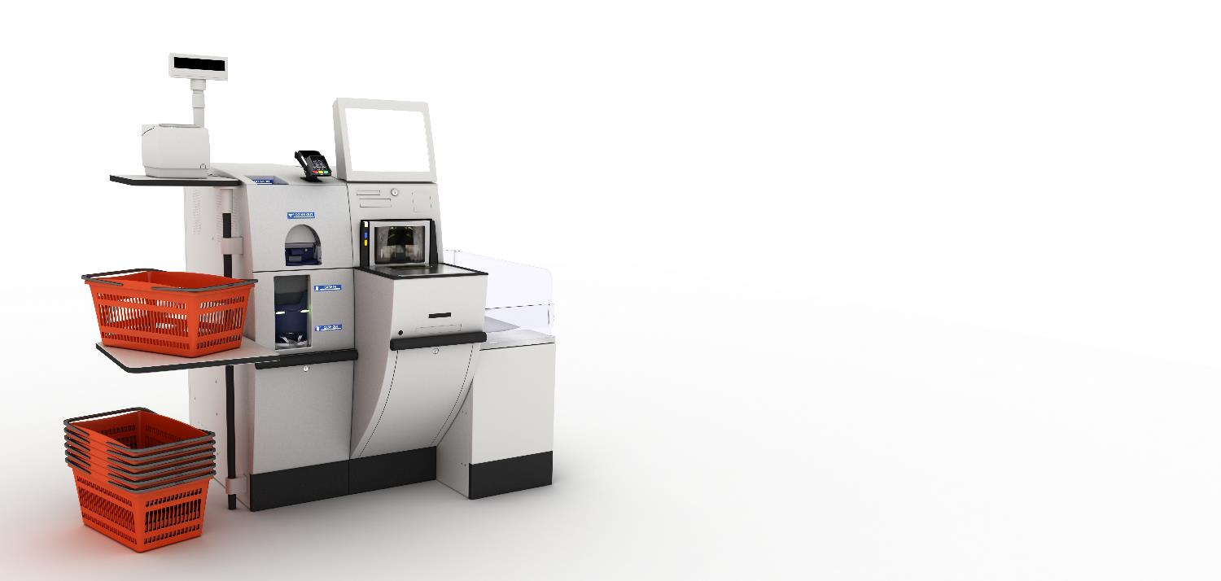

1. Identify all of the input devices at a supermarket self-checkout machine. What data is input for each device?

|  |  |
| --- | --- |
| **Input Device** | **What data is input?** |
|  |  |
|  |  |
|  |  |
|  |  |
|  |  |
|  |  |

**(Extending)**

1. What information needs to be stored on the supermarket computer in order to make everything work correctly?

1. Where might this data be stored?
2. What type of storage device could the data be stored on and why?

1. Identify the output devices at a supermarket and state what the output would be.

|  |  |
| --- | --- |
| **Output Device** | **What data is output?** |
|  |  |
|  |  |
|  |  |